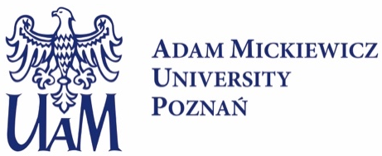
Postdoctoral researcher position
in the OPUS project 2022/45/B/NZ1/01273 entitled: "Consequences of posttranslational modifications of HYL1 for plant development".
The recently created research group led by dr Dawid Bielewicz at the Centre for Advanced Technologies, Adam Mickiewicz University in Poznań, Poland seeks a motivated Postdoctoral researcher. The successful candidate will have the opportunity to participate in cutting-edge research aiming at understanding the role of HYL1 protein in the regulation of gene expression.
About the project: In eukaryotic cells, genes regulation can be controlled at various stages, from chromatin accessibility, transcription, RNA processing to translation and protein activity. One of fundamental, sequence-specific gene expression regulatory elements are microRNAs. MicroRNA biogenesis is a multistep process and many proteins are involved in this pathway. One of them, HYL1 protein, binds double stranded RNAs and interacts with DCL1, the main RNase which releases mature microRNAs from their precursors. In cell HYL1 protein can exist in two isoforms – phosphorylated and unphosphorylated. In the OPUS project we will test the hypothesis that phosphorylated HYL1 (currently assumed as inactive pool of HYL1) is mainly involved in transcriptional gene regulation. To test our hypothesis we will apply modern methods currently used in molecular biology research i.e. next generation sequencing and fluorescence imaging using confocal microscopy.
Requirements:
Essential Requirements:
- PhD degree in biology, biotechnology, bioinformatics, or related fields.
- Strong understanding of molecular biology techniques, with a particular emphasis on mass spectrometry analysis.
- Experience in utilizing confocal microscopy.
- Scientific curiosity and a passion for research.
- Fluency in English.
- High motivation, enthusiasm, and ability to work independently.
Desirable:
- hands-on experience in bioinformatics

We offer:
6 months Initial contract with possible extension for additional 30 month, salary up to 10 000 PLN brutto/month, academic mentoring and supportive environment.

How to apply:
Please send your applications or informal inquiries to Dawid Bielewicz (dawid.bielewicz@amu.edu.pl) until 31th August 2023. Selected applicants might be invited for an interview.
The application should be prepared as a single PDF file in English and contain a one-page cover letter describing the candidate's motivation, CV Curriculum Vitae including contact detail of two academic referees.
Please add a signed consent clause to your application: In accordance with Article 6(1)(a) of the General Regulation on the Protection of Personal Data of 27 April 2016 (OJ L 119/1, 4.5.2016) I give my consent to the processing of personal data other than: first name(s) and surname; parents’ names; date of birth; place of birth; residence address (correspondence address); education; previous employment history, included in my job offer for the purpose of current recruitment.

