PhD-stipend
Institute of Molecular Biology and Biotechnology, Faculty of Biology & Center of Advanced Technologies, Adam Mickiewicz University in Poznań, Poland

We are offering research stipend for a highly motivated PhD student to join the Developmental Epigenetics Lab - new group led by Dr Michał Gdula at Adam Mickiewicz University in Poznan. You will be offered the opportunity to participate in cutting edge research aiming at understanding the role of epigenetic regulation of gene expression in development. Dr Gdula carried out research at Boston and Oxford Universities for 9 years and in his lab he implements the research practices established in those world-leading institutions. The stipend is funded by the NCN OPUS grant (2020/37/B/NZ3/04202), full-time, for four years, 2500 zł.

Project:
“The role of 3D genome folding in the establishment of keratinocyte-specific promoter-enhancer network.”
Gdula Developmental Epigenetics Lab studies the role and mechanisms of epigenetic regulation in development, cancerogenesis and DNA replication. They are are particularly interested how the three-dimensional organization of the genome within the nucleus affects cell-type specific gene activity. A typical mammalian genome consists of ~2-meter-long DNA that is contained in a nucleus with a diameter approx. 200 000 times smaller. Therefore, proper 3D genome organization is essential for the cell functioning. Gdula Lab studies how distinct configurations of 3D nuclear architecture and chromatin folding regulate expression of distinct genes. We are further interested how they implement developmental genetic programmes by re-wiring of promoter-enhancer networks.
Developmental Epigenetics Lab conducts inter-disciplinary research using a broad range of methods: classical molecular biology, cell engineering and animal models, combined with genomics, bioinformatics and advanced microscopy. Lab benefits from generous support of the NAWA and NCN funding agencies.
Your goal will be to investigate how the changes in the promoter-enhancer networks and in the architecture of the chromatin domains harboring epidermal gene clusters establish keratinocyte-specific transcription at distinct developmental windows. Experimental work will involve i.a. cell culture, work with mouse, 3D conventional/super-resolution imaging, NGS experiments and bioinformatic analysis. Please get in touch if interested in the project details.

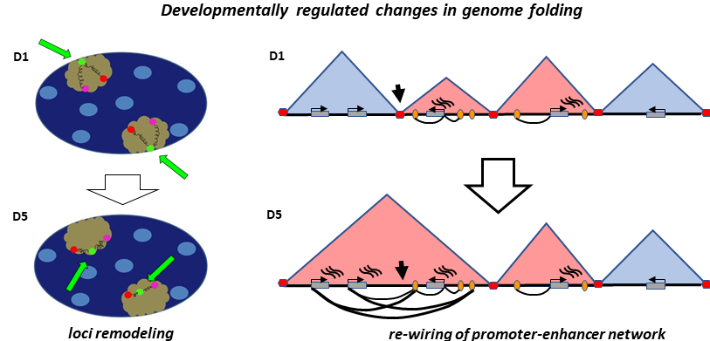

Tasks:
Leading own research project: planning and conducting molecular biology and cell culture experiments as well as computational analysis of NGS data. Presenting results in group meetings, internal seminars and conferences, manuscript preparation.

Essential qualifications:
- MSc in Molecular Biology/Biotechnology or a related science degree
- experience in standard Molecular Biology/Biochemistry techniques
- high motivation and enthusiasm for research
- high level of communication and interpersonal skills
- fluency in English

Desirable qualifications (training will be provided whenever necessary):
- experience with NGS techniques (RNA-seq, ChIP-seq, WGBS etc.)
- familiarity of chromatin conformation capture based techniques
- experience in work with animals
- experience in bioinformatics
- expertise in imaging and 3D data analysis
- co-authorship in publications from a relevant subject (e.g. epigenetics)

Interested candidates should send: a cover letter, CV and the contacts of three referees as a single pdf file to: michal.gdula@amu.edu.pl. Informal inquiries and questions welcome.
Deadline: 10th November 2023.

(!) Please include in the CV and covering letter the following statement: In accordance with Article 6(1)(a) of the General Data Protection Regulation of 27 April 2016 (Journal of Laws of the EU L 119/1 of 4 May 2016) I agree to the processing of personal data other than those indicated in Article 221 of the Labour Code (name(s) and surname; parents' names; date of birth; place of residence; address for correspondence; education; previous employment), included in my job offer for the purpose of current recruitment.

Lab webpage:
http://ibmib.home.amu.edu.pl/en/department-of-gene-expression/developmental-epigenetics-lab/

Publications:
Nat Commun 10, 30 (2019)
Mol Cell 74, 158-172.e9 (2019)
Journal of Investigative Dermatology 133, 2191–2201 (2013)
Journal of Investigative Dermatology 132, 2505–2521 (2012)
Development 141, 101–111 (2014)
J. Cell Biol. 194, 825–839 (2011)
PLOS Genetics 13, e1006966 (2017)

About the Faculty of Biology at Adam Mickiewicz University in Poznań

The Faculty of Biology at Adam Mickiewicz University (FB AMU, @UAM_IBMiB) has excellent organizational capability and experience in the field of project implementation. FB AMU is a leading research and education institution in Poland. It currently holds the top A+ (outstanding) national research category and is best ranked among large classical university faculties. CWTS Leiden Ranking 2020 indicated AMU as third University in Poland in number of publications but second in number of publications belonging to top 10% in the category „Life and Earth Sciences”. According to THE World University Ranking 2020 AMU was the second best Polish university in category “Life Sciences”. Since the setting-up of the National Science Centre (Narodowe Centrum Nauki, NCN) funding agency in Poland, FB AMU has been one of its main research grants beneficiaries. FB grants account for 30% of all Adam Mickiewicz University grants; on average over 100 NCN research grants are pursued at FB AMU each year.

The Institute of Molecular Biology and Biotechnology (IMBB) is the biggest of four Institutes at FB AMU. The expertise of IMBB encompasses several major fields of modern biology that can be further subdivided into: (1) Plant molecular biology and biotechnology, (2) Molecular medicine and gene therapy, (3) Molecular microbiology, and (4) Bioinformatics and molecular evolution. In the last few years FB AMU has supported the creation of 18 new research groups, 15 of those were formed in IMBB. The group leaders were mainly recruited externally, many came from abroad.
Faculty of Biology

The Developmental Epigenetics Lab is physically located at and affiliated with The Centre of Advanced Technologies at Adam Mickiewicz University (CAT AMU) located ~500m from the IMBB. CAT AMU is the collaborative multi-disciplinary institute funded with 63mln € (85% from EU funds). Group of Dr Gdula benefits from its facilities including confocal microscope, cell sorter and state of the art Animal Facility.
Centre of Advanced Technology
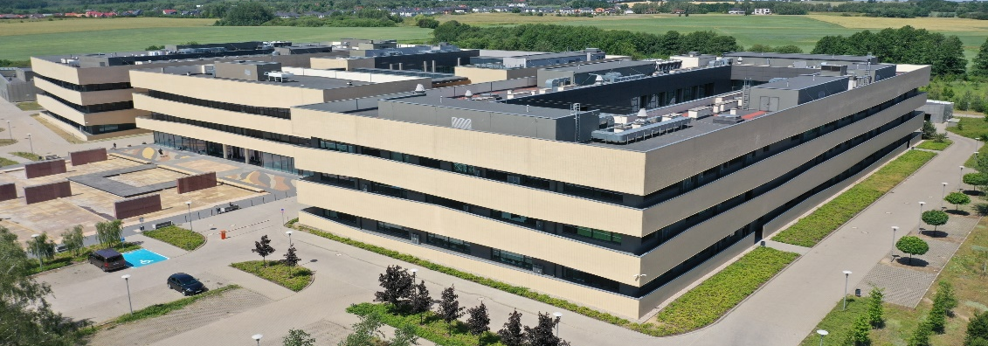

Information clause for jobseekers
Pursuant to Article 13 of Regulation (EU) No. 2016/679 of the European Parliament and of the Council of 27 April 2016 on the protection of individuals with regard to the processing of personal data and on the free movement of such data and repealing Directive 95/46/EC - General Regulation on data protection (Official Journal of the European Union L 119/1 of 04.05.2016) I hereby inform you that.

1. The Controller of your personal data is Adam Mickiewicz University in Poznań with its registered office at 1, Henryka Wieniawskiego Street, 61-712 Poznań.
2. The controller of personal data has appointed a Data Protection Inspector to supervise the correctness of personal data processing, who can be contacted via e-mail address: iod@amu.edu.pl.
3. The purpose of the processing of your personal data is to carry out the recruitment process for the indicated position.
4. The legal basis for the processing of your personal data is Article 6(1)(a) of the General Data Protection Regulation of 27 April 2016 and the Labour Code of 26 June 1974 (Journal of Laws of 1998, N21, item 94, as amended).
5. Your personal data will be stored for a period of 6 months from the end of the recruitment process.
6. Your personal data will not be made available to other entities, except for entities authorized by law. Access to your data will be granted to persons authorized by the Controller to process them within the scope of their professional duties.
7. You have the right to access your data and, subject to the provisions of law, the right to rectify, delete, restrict the processing, the right to transfer data, the right to object to the processing, the right to withdraw consent at any time.
8. You have the right to lodge a complaint to the supervisory authority - the President of the Office for Personal Data Protection, ul. Stawki 2, 00-193 Warszawa.
9. Provision of personal data is obligatory on the basis of legal regulations, in the remaining scope it is voluntary.
10. With regard to your personal data, decisions will not be taken automatically, in accordance with Article 22 RODO.

