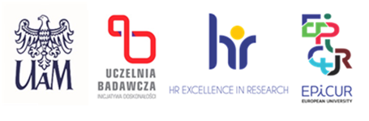

Date: 29.08.2025

**INFORMATION ON THE RESULT OF THE COMPETITION**

(sent over to HR)

|  |  |
| --- | --- |
| FACULTY  **i**n the project……..  number……**…..** | Faculty of Psychology and Cognitive Science, AMU; “The Effects of Generative Artificial Intelligence  on Higher-Order Cognitive Functions”;  2024/53/B/HS6/02797 |
| POSITION | Postdoctoral Researcher |

As a result of the proceedings in the competition conducted for the above mentioned post, following a secret ballot vote, the competition committee has chosen Ms. Agata Dymarska.

Justification (formulated by the competition committee):

The competition committee has analyzed submitted documents. The documents submitted by the Candidate in the recruitment procedure met formal and substantive requirements. The Candidate met all the eligibility criteria established in the competition. The competition committee thus recommends the Candidate for the position of an Postdoctoral Researcher.

Dawid Ratajczyk

(First and last name of the chairperson of the competition committee)