PhD student position

We are seeking a highly motivated PhD student to join the Zebrafish developmental neurobiology research group led by Dr Savani Anbalagan at the Adam Mickiewicz University, Poznań, Poland, supported by NCN Sonata-BIS project.
Astrocyte cells are major players in nervous system development and functioning. Neurohypophyseal (posterior pituitary) glial pituicytes are astrocyte-like cells that promote local axonal and vascular morphogenesis, enable release of neuropeptides Oxytocin and Vasopressin into the peripheral circulation. Our group studies the role of glial pituicyte-derived paracrine signaling molecules that regulate neurohypophyseal morphogenesis using zebrafish as vertebrate organism.
The project will take advantage of the genetic amenability of zebrafish and optical transparency to understand how glial pituicyte-derived factors regulate local axonal morphogenesis. Using our recently developed CRISPR mutants and by generating novel transgenic fish lines, we will study how pituicytes regulates axonal morphogenesis. We will use advanced light microscopy techniques for characterizing the phenotypes.
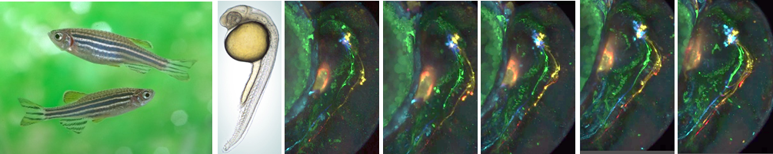

Requirements:
- Master’s degree in life science field (biology, biotechnology or related)
- Hands-on experience in molecular biology skills
- Oral and written proficiency in English.
- High motivation, initiative, enthusiasm, and readiness to learn new skills
- Experience in working with zebrafish is not mandatory.
We offer:
- Supportive environment, 4-year funded position, scientific stipend 1900 zł
- Access to state-of-the art facilities
How to apply:
- Interested candidates should e-mail the following documents to Dr Savani Anbalagan savanb@amu.edu.pl
  - motivation letter,
  - CV with educational and scientific achievements,
  - MSc diploma
  - Name and contact details of two academic referees

Application deadline: 29th November 2022
For more information: https://zfin.org/ZDB-LAB-210827-1
Please add signed consent clause in your application: ‘’I hereby give consent for my personal data included in my application to be processed for the purposes of the recruitment process under the Regulation (EU) 2016/679 of the European Parliament and of the Council of 27 April 2016 on the protection of natural persons with regard to the processing of personal data and on the free movement of such data, and repealing Directive 95/46/EC (General Data Protection Regulation).’’

Information clause for jobseekers

Pursuant to Article 13 of Regulation (EU) No. 2016/679 of the European Parliament and of the Council of 27 April 2016 on the protection of individuals with regard to the processing of personal data and on the free movement of such data and repealing Directive 95/46/EC - General Regulation on data protection (Official Journal of the European Union L 119/1 of 04.05.2016) I hereby inform you that.

1. The Controller of your personal data is Adam Mickiewicz University in Poznań with its registered office at 1, Henryka Wieniawskiego Street, 61-712 Poznań.

2. The controller of personal data has appointed a Data Protection Inspector to supervise the correctness of personal data processing, who can be contacted via e-mail address: iod@amu.edu.pl.

3. The purpose of the processing of your personal data is to carry out the recruitment process for the indicated position.

4. The legal basis for the processing of your personal data is Article 6(1)(a) of the General Data Protection Regulation of 27 April 2016 and the Labour Code of 26 June 1974 (Journal of Laws of 1998, N21, item 94, as amended).

5. Your personal data will be stored for a period of 6 months from the end of the recruitment process.

6. Your personal data will not be made available to other entities, except for entities authorized by law. Access to your data will be granted to persons authorized by the Controller to process them within the scope of their professional duties.

7. You have the right to access your data and, subject to the provisions of law, the right to rectify, delete, restrict the processing, the right to transfer data, the right to object to the processing, the right to withdraw consent at any time.

8. You have the right to lodge a complaint to the supervisory authority - the President of the Office for Personal Data Protection, ul. Stawki 2, 00-193 Warszawa.

9. Provision of personal data is obligatory on the basis of legal regulations, in the remaining scope it is voluntary.

10. With regard to your personal data, decisions will not be taken automatically, in accordance with Article 22 RODO

