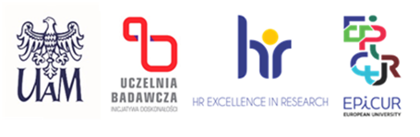

Date: 17.09.2025

**INFORMATION ON THE RESULT OF THE COMPETITION**

(sent over to HR)

|  |  |
| --- | --- |
| FACULTY  **i**n the project  number | Faculty of Chemistry  Design, characterization, and the performance mechanism description of heterostructured semiconductor materials in photocatalytic systems and dye-sensitized photovoltaic cells  2024/53/B/ST5/01357 |
| POST | assistant professor-postdoctoral trainee (post-doc) |

As a result of the proceedings in the competition conducted for the abovementioned post, following a secret ballot vote, the competition committee has chosen Mr. Bartosz Zawadzki

Justification (formulated by the competition committee):

The competition committee has analyzed submitted documents. The documents submitted by the Candidate in the recruitment procedure met formal and substantive requirements. The Candidate met all the eligibility criteria established in the competition. The competition committee thus recommends the Candidate for the position of an assistant professor-postdoctoral trainee (post-doc)

Maciej Zalas

(First and last name of the chairperson of the competition committee)