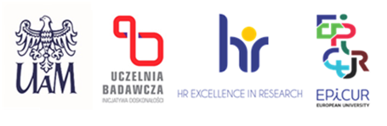

Date: May 13th, 2025

**INFORMATION ON THE RESULT OF THE COMPETITION**

(sent over to HR)

|  |  |
| --- | --- |
| FACULTY  **i**n the project  number | Faculty of Chemistry  Design, characterization, and the performance mechanism description of heterostructured semiconductor materials in photocatalytic systems and dye-sensitized photovoltaic cells  2024/53/B/ST5/01357 |
| POST | assistant professor-postdoctoral trainee (post-doc) |

As a result of the proceedings in the competition conducted for the above-mentioned post, following a secret ballot vote, the competition committee has not chosen any candidate.

Justification (formulated by the competition committee):

The competition committee has analyzed the submitted documents. The documents submitted by the Candidates in the recruitment procedure met formal and substantive requirements. None of the candidates met all the eligibility criteria established in the competition. The competition committee thus does not recommend any Candidate for the position of an assistant professor-postdoctoral trainee (post-doc)

Maciej Zalas

(First and last name of the chairperson of the competition committee)